Unit-wise Notes

Course Code : 417523
Course Name : Elective – III Quantum Artificial Intelligence
Semester : I

Course Objectives:
- To get acquainted with the principles of quantum computing and the usage of Linear
algebra in Quantum Computing
- To understand the Architecture of Quantum computing and solve examples of Quantum Fourier Transforms
- To understand the concepts of basic and advanced Quantum Algorithms and apply them to various problems.
- To study quantum machine learning and apply these to develop hybrid solutions
- To study the Quantum Theory with Fault-Tolerant Quantum techniques
- To understand Problem-Solving using various peculiar search strategies for AI

Course Outcomes:

CO1: Understand quantum requirements and formulate design solutions using quantum circuits.
CO2: Illustrate applicable solutions in one or more application domains using a quantum
architecture that integrates ethical, social, and legal concerns
CO3: Apply the Advanced Quantum Algorithms on real time problem
CO4: Analyze the quantum machine learning algorithms and their relevant application
CO5: Analyze quantum information processing & its relevant algorithms
CO6: Evaluate suitable algorithms for AI problems

Unit 1 Introduction to Quantum Computation
Artificial Intelligence is the study to provide human intelligence artificially to the machines. Artificial intelligence provides machines the ability to make decisions according to its own intelligence to perform the specified task.
Quantum computing is completely based on the quantum theory. Quantum computing is primarily used for complex computations. It makes the computation faster and provides the efficient results.
Quantum Computer
A computer that uses laws of quantum mechanics to perform massively parallel computing through superposition, entanglement, and decoherence.
Classical Computer
A computer that uses voltages flowing through circuits and gates, which can be controlled and manipulated entirely by classical mechanics.
Brief History of Quantum Computers :
- 1959 : Quantum computing tends to trace its roots back to a 1959 speech by Richard P. Feynman in which he spoke about the idea of exploiting quantum effects to create more powerful computers.
- 1981:Richard Feynman proposed to use quantum computing to model quantum systems. He also describe theoretical model of quantum computer.
- 1985: David Deutsch described first universal quantum computer
- 1994: Peter Shor developed the first algorithm for quantum computer (factorization into primes)
- 1995 Schumacher proposed “Quantum bit” or “qubit” as physical resource
- 1996:LovGrover developed an algorithm for search in unsorted database
- 1998: the first quantum computers on two qubits, based on NMR(Oxford; IBM, MIT, Stanford)
- 2000: quantum computer on 7 qubits, based on NMR (Los-Alamos)
- 2001: 15 = 3 x5 on7-qubit quantum computer by IBM
- 2005-2006: experiments with photons; quantum dots; fullerenes and nanotubes as "particle traps"
Classical Mechanics
•It deals with macroscopic particles
•It is based on Newton’s laws of motion and Maxwell’s electromagnetic wave theory
•Any amount of energy may be emitted or absorbed continuously
•The state of a system is defined exactly by specifying their positions and velocities
•The future state can be predicted with certainty
Quantum Mechanics
•It deals with microscopic particles
•It is based on the Schrödinger equation
•In Planck’s postulation, only discrete values of energy are emitted or absorbed –origin of “quantum”
•Because of Heisenberg’s uncertainty principleand de Broglie hypothesisdual nature of matter (both particle & wave), the state of a system cannot be specified exactly
- It gives probabilities of finding particles at various locations in space

Quantum Computing :
Quantum computing is the computer technology based on the principles of quantum theory, which explains the nature and behaviour of energy and matter on the quantum (atomic and subatomic) level. Quantum computing is essentially harnessing and exploiting the amazing laws of quantum mechanics to process information
A classical binary bit is always in one of two states—0 or 1—while a quantum bit or qubit exists in both of its possible states at once, a condition known as a superposition.
An operation on a qubit thus exploits its quantum weirdness by allowing many computations to be performed in parallel.
A two-qubit system would perform the operation on 4 values, a three-qubit system on 8 and so forth.

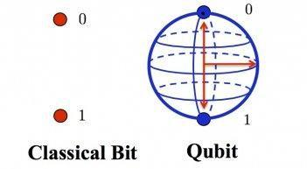
A qubit (short for quantum bit) is the basic unit of information in quantum computing and counterpart to the bit (binary digit) in classical computing.
In a quantum computer, a number of elemental particles such as electrons or photons can be used (in practice, success has also been achieved with ions), with either their charge or polarization acting as a representation of 0 and/or 1.
Each of these particles is known as a qubit; the nature and behavior of these particles (as expressed in quantum theory) form the basis of quantum computing.
Rather than performing each calculation in turn on the current single state of its bits, as a classical computer does, a quantum computer's sequence of qubits can be in every possible combination of 1s and 0s at once.
This allows the computer to test every possible solution simultaneously and to perform certain complex calculations exponentially faster than a classical computer.
One curious feature of a qubit is that measuring it causes it to "collapse" into a single classical known state—0 or 1 again—and lose its quantum properties.
Two of the most relevant aspects of quantum physics are the principles of superposition and entanglement.
Superposition property :
It enables a quantum computer to be in multiple states at once.
Superposition is the ability of a quantum system to be in multiple states at the same time until it is measured.
The number of possible states grows exponentially as the number of qubits increases.
The possible states are represented as 2^n, where is the number of qubits. The following table shows the number of possible states for five qubit amounts: 2^5 = 32 possible states.
Entanglement :
In Quantum Mechanics, it sometimes occurs that a measurement of one particle will effect the state of another particle, even though classically there is no direct interaction. (This is a controversial interpretation).
When this happens, the state of the two particles is said to be entangled.
Entanglement is the ability of quantum systems to exhibit correlations between states within a superposition.
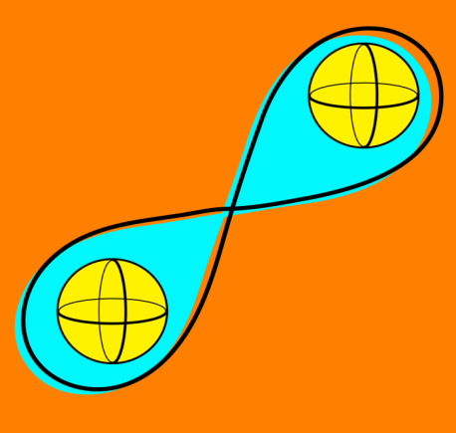Imagine two qubits, each in the state |0> + |1> (a superposition of the 0 and 1.) We can entangle the two qubits such that the measurement of one qubit is always correlated to the measurement of the other qubit.

Qubit gates in quantum computation :
In quantum computation, qubits (quantum bits) are the fundamental units of information. They possess unique properties due to their quantum nature, allowing them to exist in superpositions of classical states and be entangled with other qubits. Single qubit gates are fundamental quantum operations that act on a single qubit, manipulating its quantum state. These gates play a crucial role in constructing quantum circuits and performing quantum computations.
Single qubit gates operate on the quantum state of a qubit, which can be represented using a mathematical notation called a state vector. The state vector represents the probabilities of finding the qubit in different classical states (usually denoted as |0⟩ and |1⟩). However, due to quantum superposition, a qubit can exist in a linear combination of these classical states, represented as:

|ψ⟩ = α|0⟩ + β|1⟩
Here, α and β are complex probability amplitudes, and their magnitudes squared (|α|^2 and |β|^2) represent the probabilities of measuring the qubit in the corresponding states.
In quantum computing and specifically the quantum circuit model of computation, a quantum logic gate (or simply quantum gate) is a basic quantum circuit operating on a small number of qubits.
- All operations in classical computing are based on logic gates.
- For example, the logical AND gate takes in two bits and returns 1 if and only if both inputs are 1.
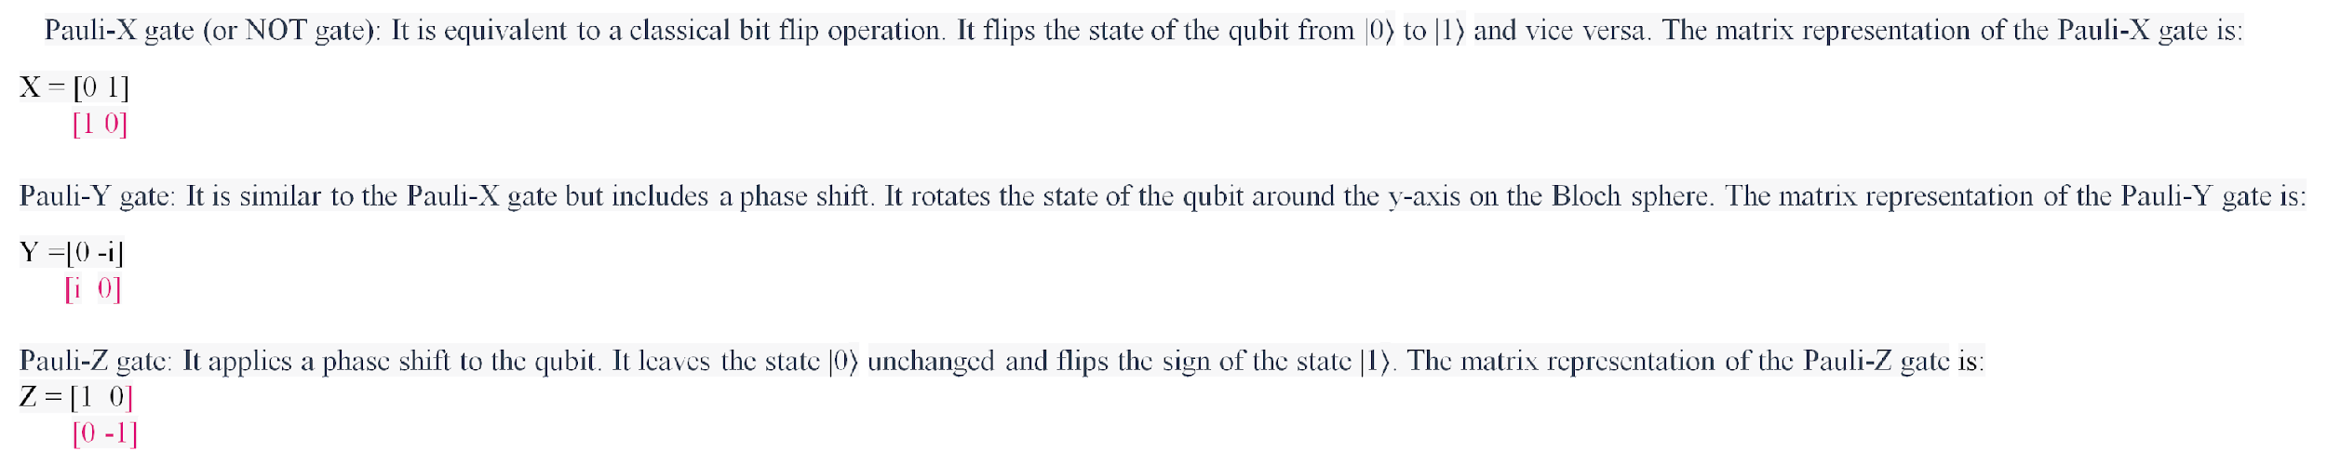
Hadamard gate: It creates superposition by evenly distributing the probability between the |0⟩ and |1⟩ states. It rotates the qubit by 180 degrees around the x-axis and 90 degrees around the z-axis on the Bloch sphere. The matrix representation of the Hadamard gate is:
H = [1 1]
[1 -1] * 1/sqrt(2)
Phase gate (or S gate): It introduces a phase shift of 90 degrees to the state |1⟩. It is commonly used to construct other gates. The matrix representation of the Phase gate is:
S = [1 0]
[0 i]
T gate: It introduces a phase shift of 45 degrees to the state |1⟩. It is also used to construct other gates. The matrix representation of the T gate is:
T= [1 0]
[0 e^(iπ/4)]

Multiple Qubit Gates
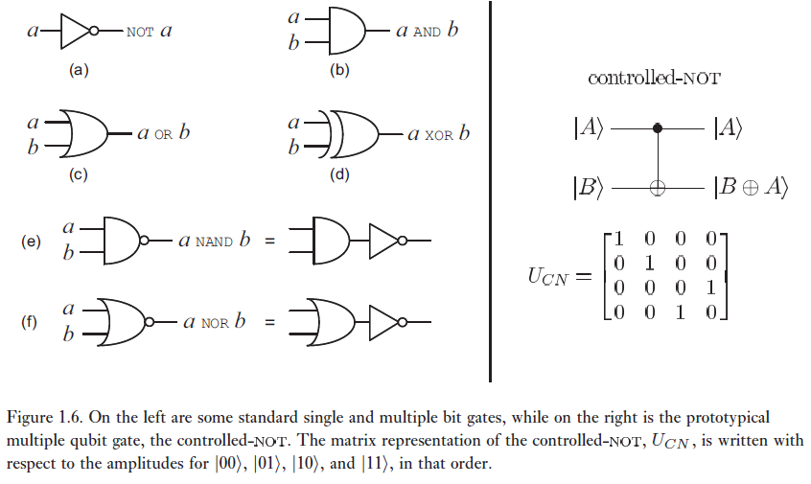
Multiple qubit gates, also known as multi-qubit gates or two-qubit gates, are quantum logic gates that operate on two or more qubits in a quantum computing system.
These gates allow for the interaction and entanglement of multiple qubits, enabling more complex computations.
Types of multiple qubit gates:
1. CNOT (Controlled-NOT) gate:
The CNOT gate is a two-qubit gate that applies a NOT gate (Pauli-X gate) to the target qubit if and only if the control qubit is in the state |1⟩. It flips the target qubit's state when the control qubit is |1⟩, while leaving it unchanged when the control qubit is |0⟩. The CNOT gate is commonly represented as:
CNOT = [1 0 0 0]
[0 1 0 0]
[0 0 0 1]
[0 0 1 0]
2. SWAP gate:
The SWAP gate exchanges the states of two qubits. It swaps the values of two qubits, such that the state of the first qubit becomes the state of the second qubit, and vice versa. The SWAP gate is represented as:
SWAP = [1 0 0 0]
[0 0 1 0]
[0 1 0 0]
[0 0 0 1]
3. Controlled-phase gate (CZ gate):
The CZ gate, also known as the controlled-Z gate, applies a phase shift of π radians to the target qubit if and only if the control qubit is in the state |1⟩. It leaves the target qubit unchanged when the control qubit is |0⟩. The CZ gate is represented as:
CZ = [1 0 0 0]
[0 1 0 0]
[0 0 1 0]
[0 0 0 -1]

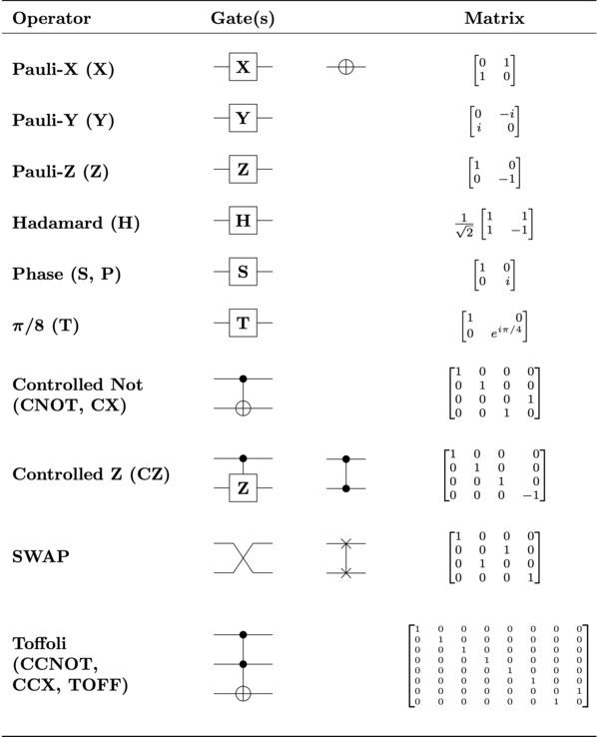

Measurements in bases Vs computational basis
In quantum computing, measurements can be performed in different bases, including the computational basis.
Let's explore the difference between measurements in different bases.

1. Computational Basis Measurements:
In the computational basis, measurements are performed in the standard basis states |0⟩ and |1⟩.
When a qubit is measured in the computational basis, it collapses into one of the basis states with probabilities determined by the amplitudes of the qubit's quantum state.
For example, if a qubit is in the state α|0⟩ + β|1⟩,
where α and β are probability amplitudes,
the measurement will yield |0⟩ with
probability |α|^2 and |1⟩ with probability |β|^2.

2. Measurements in Other Bases:

Apart from the computational basis, measurements can also be performed in other bases, which are defined by different sets of states.
These bases are often represented by sets of orthogonal states that span the same Hilbert space.
Examples of alternative bases include the Hadamard basis, Pauli basis, or any other orthonormal basis.

When performing a measurement in an alternative basis, the qubit's quantum state is first transformed into that basis using appropriate quantum gates. Then, the measurement is carried out in the transformed basis.
This can be achieved by applying a unitary gate that performs a basis transformation, followed by a measurement in the computational basis.

Qubits
- Data is carried out by quantum bits or qubits
- Physical Object: ions, photons, etc.
Quantum Gates
- Single-qubit: H (Hadamard gate), X (NOT gate)
- Two-qubit: CNOT (Controlled NOT), SWAP
Quantum Circuit

q₀
q₁
q₂
X

q₃

Circuit swapping two qubits :-

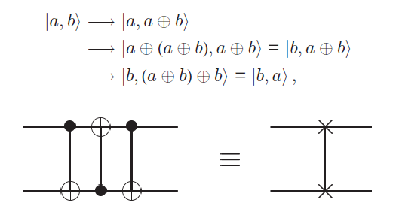

Quantum circuits:

Quantum circuits are a graphical representation of quantum computations or algorithms. They consist of a series of quantum gates applied to qubits, along with measurements and classical operations. Quantum circuits provide a way to visually describe the flow of quantum information and transformations.
Components of a Quantum Circuit:
1. Qubits: Qubits are the basic units of quantum information. They represent the quantum analog of classical bits and can exist in superposition, allowing for simultaneous representation of multiple states.
2. Quantum Gates: Quantum gates are operations that act on qubits and manipulate their states. These gates include single-qubit gates (e.g., Pauli gates, Hadamard gate) and multi-qubit gates (e.g., CNOT gate, SWAP gate). Each gate corresponds to a unitary transformation that evolves the quantum state.
3. Quantum Registers: Quantum registers are collections of qubits grouped together to perform operations collectively. They allow for the manipulation of multiple qubits simultaneously.
4. Measurements: Measurements in quantum circuits extract classical information from qubits. They collapse the quantum state to a classical outcome, providing measurement results that can be interpreted as classical bits.
5. Classical Operations: Quantum circuits may also include classical operations, such as classical gates and classical bits, to perform classical computations or process measurement results obtained from quantum operations.

Representation of Quantum Circuits:
Quantum circuits are typically represented using circuit diagrams. In these diagrams, qubits are represented by horizontal lines, and gates are represented by specific symbols corresponding to their operations.
The direction of time is from left to right, indicating the flow of computation.
Quantum circuits can be composed of multiple layers or levels, where gates in the same layer are applied simultaneously, and information can flow from one layer to the next.
This layer-based structure allows for parallel and sequential execution of quantum operations.

Qubit copying circuit :
In quantum computing, the no-cloning theorem states that it is impossible to create an exact copy of an arbitrary unknown quantum state. This means that you cannot directly copy a qubit in the same way you can copy classical bits.
However, there is a concept known as quantum teleportation that allows for the transfer of quantum information from one qubit to another. Quantum teleportation is a protocol that can be used to transmit the state of a qubit to a distant location without physically sending the qubit itself.
The basic idea behind quantum teleportation involves two parties: the sender (Alice) and the receiver (Bob), who share an entangled pair of qubits known as a Bell pair. Here is a high-level description of the quantum teleportation circuit:
- Alice and Bob share an entangled Bell pair of qubits, where each qubit is in a superposition of states: |00⟩ + |11⟩.
- Alice wants to send her qubit (let's call it qubit A) to Bob.
- Alice applies a controlled NOT (CNOT) gate to her qubit A, controlled by the state of the qubit she wants to send (let's call it qubit C), and then applies a Hadamard gate to qubit C. This operation is known as a Bell measurement.
- Alice measures the states of qubits A and C.
- Alice sends the measurement results (two classical bits) to Bob through a classical communication channel.
- Based on the measurement results, Bob performs certain operations on his qubit (let's call it qubit B) to transform it into the desired state that was originally held by Alice's qubit A.
Note that the actual implementation of quantum teleportation involves specific quantum gates and operations, but this high-level description should give you an idea of the process.
It's important to emphasize that quantum teleportation doesn't involve copying the quantum state itself but rather transferring the state to another qubit through the entanglement of qubits.

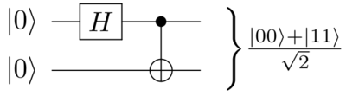

Examples- Bell states:
Bell states, also known as EPR pairs or maximally entangled states, are specific quantum states that play a crucial role in various quantum information protocols, including quantum teleportation and quantum cryptography. These states are formed by two qubits that are maximally entangled, meaning their quantum states are correlated in a highly non-classical way.
There are four Bell states, each represented by a combination of the states of two qubits, usually denoted as |Φ⁺⟩, |Φ⁻⟩, |Ψ⁺⟩, and |Ψ⁻⟩. The general form of a Bell state is:
|Φ⁺⟩ = 1/√2 (|00⟩ + |11⟩)
|Φ⁻⟩ = 1/√2 (|00⟩ - |11⟩)
|Ψ⁺⟩ = 1/√2 (|01⟩ + |10⟩)
|Ψ⁻⟩ = 1/√2 (|01⟩ - |10⟩)
Here, |00⟩, |01⟩, |10⟩, and |11⟩ represent the basis states of two qubits in the computational basis.
The coefficients 1/√2 ensure that the total probability of the system remains normalized.

These Bell states possess interesting properties. For example, if two qubits are in a Bell state and one of them is measured, the measurement result instantaneously determines the state of the other qubit, regardless of the spatial separation between them. This property is known as "quantum entanglement" and forms the basis of many quantum information processing tasks.
Bell states are typically generated using quantum gates and operations. For example, applying a Hadamard gate (H) to the first qubit and a controlled-NOT gate (CNOT) with the first qubit as the control and the second qubit as the target can create the Bell state |Φ⁺⟩.
It's worth noting that Bell states are just one example of entangled states, and they have important applications in quantum computing, quantum communication, and quantum cryptography.
Example - Quantum teleportation :
Quantum teleportation is a quantum communication protocol that allows the transfer of an unknown quantum state from one qubit to another, without physically transporting the qubit itself. It relies on the principles of entanglement and quantum measurement. The basic idea behind quantum teleportation is as follows:
- Initialization: Alice and Bob, the sender and receiver, respectively, share an entangled pair of qubits called a Bell pair. The Bell pair is typically in one of the four Bell states: |Φ⁺⟩, |Φ⁻⟩, |Ψ⁺⟩, or |Ψ⁻⟩.
- State Preparation: Alice possesses the qubit (let's call it qubit A) that she wants to teleport to Bob, while Bob has an empty qubit (let's call it qubit B) that will receive the teleported state.
- Bell Measurement: Alice performs a joint measurement, known as a Bell measurement, on her qubit A and the entangled qubit of the Bell pair.
- Measurement Results: Alice obtains two classical bits as the measurement outcomes, which convey information about the state of her qubit A.
- Classical Communication: Alice sends the two classical bits to Bob through a classical communication channel.
- Bob's Operations: Based on the received measurement results, Bob performs a specific set of operations (quantum gates) on his qubit B to transform it into the exact replica of Alice's original qubit A.
Through this protocol, the quantum state of qubit A is faithfully transmitted to qubit B in Bob's possession. It's important to note that the actual qubit A is not physically transmitted or cloned in the process. Instead, the entangled Bell pair and the classical communication of measurement results enable the transfer of the quantum information.
Quantum teleportation has practical applications in quantum computing and quantum communication, particularly for transmitting quantum states over long distances in a secure and efficient manner.

Basics of Linear Algebra: Hilbert Spaces
In linear algebra, a Hilbert space is a complete inner product space. It is named after the German mathematician David Hilbert. Hilbert spaces are central to the study of functional analysis and quantum mechanics.
Key concepts related to Hilbert spaces:
Inner Product: An inner product is a mathematical operation defined on vectors that generalizes the dot product. It takes two vectors and returns a scalar value. In a Hilbert space, the inner product is a linear operation that satisfies certain properties, such as linearity in the first argument and conjugate symmetry.
Norm: The norm of a vector in a Hilbert space is a measure of its length or magnitude. It is derived from the inner product and satisfies properties like positivity, triangle inequality, and homogeneity. The norm of a vector is denoted by ||x||.
Complete Space: A Hilbert space is complete, which means that every Cauchy sequence (a sequence in which the elements get arbitrarily close to each other) in the space converges to a limit that is also in the space. Completeness is an important property that ensures the existence of limits in the space.
Orthogonality: Two vectors in a Hilbert space are said to be orthogonal if their inner product is zero. Orthogonal vectors are perpendicular to each other, similar to how perpendicular lines are orthogonal in Euclidean geometry.
Orthonormal Basis: An orthonormal basis is a set of vectors in a Hilbert space that are orthogonal to each other and have unit norm. Any vector in the Hilbert space can be expressed as a linear combination of the basis vectors.
Projection: In a Hilbert space, the projection of a vector onto a subspace is a vector that minimizes the distance between the original vector and the subspace. The projection can be computed using the inner product and orthogonality properties.
Self-Adjoint Operators: In Hilbert spaces, operators are linear mappings that transform vectors into other vectors. A self-adjoint operator is an operator that is equal to its own adjoint, where the adjoint is the operator obtained by taking the conjugate transpose. Self-adjoint operators have many important properties and play a crucial role in quantum mechanics.
These are just some of the basic concepts related to Hilbert spaces in linear algebra.

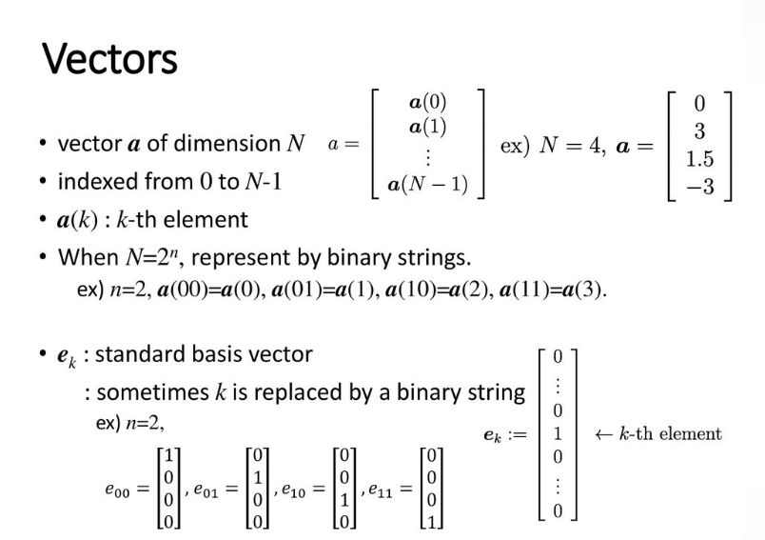

Hilbert Space :-
In a Hilbert space, the norm of a vector is a mathematical concept that quantifies the "length" or "size" of the vector. A Hilbert space is a complete inner product space, meaning it's a vector space equipped with an inner product (a generalization of the dot product in Euclidean space) that is also complete with respect to the metric induced by that inner product. Hilbert spaces are foundational in various areas of mathematics and physics, including functional analysis and quantum mechanics.
The norm of a vector v in a Hilbert space is denoted by ‖v‖ or ||v||. It is defined using the inner product of the space, typically using the square root of the inner product of the vector with itself:
‖v‖ = √(⟨v | v⟩)
Here, ⟨v | v⟩ represents the inner product of the vector v with itself.
The norm satisfies the following properties for all vectors u and v in the Hilbert space and scalar α:
Non-negativity: ‖v‖ ≥ 0
Definiteness: ‖v‖ = 0 if and only if v = 0, the zero vector.
Homogeneity: ‖αv‖ = |α|‖v‖
Triangle inequality: ‖u + v‖ ≤ ‖u‖ + ‖v‖
The norm in a Hilbert space plays a role similar to the magnitude of a vector in Euclidean space. It allows us to measure the size of vectors, compare their lengths, and define notions of distance and convergence in the Hilbert space.
In the context of quantum mechanics, the norm of a quantum state vector is used to ensure that probabilities are conserved. The square of the norm of a quantum state vector gives the probability of measuring that state in a certain outcome.
Different norms can be defined based on different metrics and inner products, leading to different notions of length and distance in the Hilbert space. The most common norm used is the Euclidean norm, which is derived from the Euclidean inner product.
The concept of norms in Hilbert spaces is a fundamental aspect of functional analysis, a branch of mathematics that deals with vector spaces of functions and their properties. It has profound implications in understanding various mathematical and physical systems.
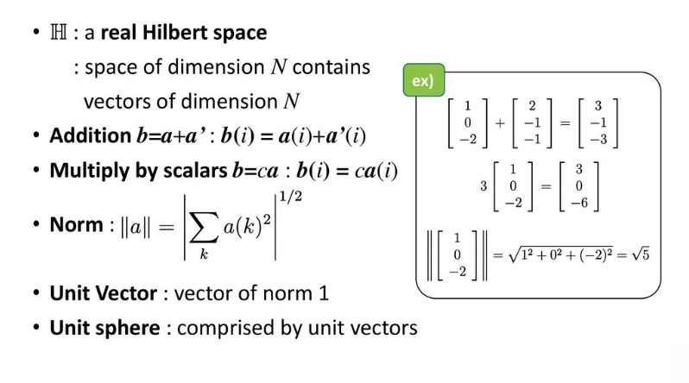
Tensor Product:-
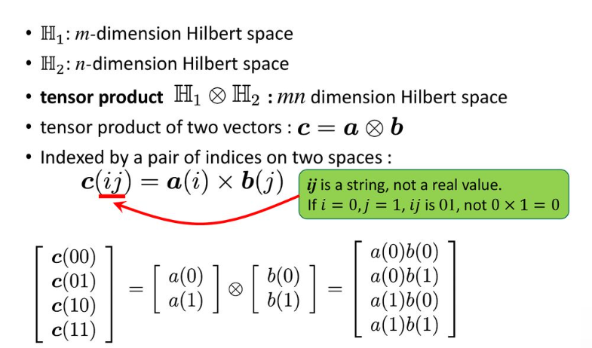

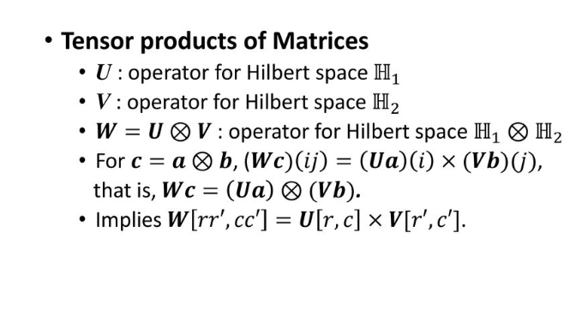
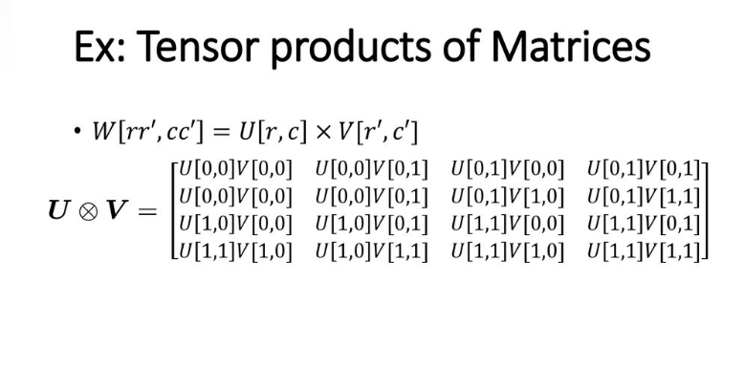

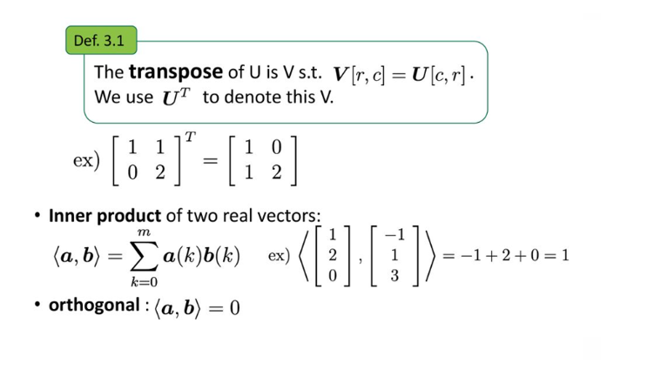
Inner product of two real vectors :

The inner product of two real vectors in an n-dimensional Euclidean space is a mathematical operation that results in a scalar (a single real number). The inner product, also known as the dot product or scalar product, measures the similarity or alignment between the two vectors.

For two real vectors u and v in an n-dimensional space, the inner product is calculated as the sum of the products of their corresponding components:

u ⋅ v = u₁v₁ + u₂v₂ + ... + uₙvₙ

Here, u₁, u₂, ..., uₙ are the components of vector u, and v₁, v₂, ..., vₙ are the components of vector v.

The dot product can also be represented using matrix notation. If u and v are column vectors, then their dot product can be written as a matrix multiplication:

u ⋅ v = uᵀ v

Here, uᵀ is the transpose of vector u (a row vector), and v is the column vector.

The dot product has various applications in mathematics, physics, engineering, and computer science. In physics, it's used to calculate work, find the angle between vectors, and determine the projection of one vector onto another. In computer graphics, it's used for lighting calculations and determining the similarity between vectors.

When working with complex vectors in certain contexts, such as quantum mechanics, the concept of the inner product extends to the complex inner product, where the conjugate of one of the vectors is taken into account. However, for real vectors, the inner product is the simple dot product described above.

Consider two real vectors:

u = [2, 5, 3]
v = [1, -4, 6]

To find the inner product (dot product) of these vectors, we'll multiply their corresponding components and sum up the results:

u ⋅ v = u₁v₁ + u₂v₂ + u₃v₃
= (2)(1) + (5)(-4) + (3)(6)
= 2 - 20 + 18
= 0

So, the inner product of u and v is 0.

In this example, the inner product of the two vectors is 0, indicating that they are orthogonal (perpendicular) to each other. This means that the angle between these vectors is 90 degrees.

Orthogonal vectors have a dot product of 0, but it's important to note that a dot product of 0 does not necessarily mean that the vectors are orthogonal. It's possible for non-orthogonal vectors to also have a dot product of 0 if their directions cancel out in a way that their contributions to the dot product are equal and opposite.

The inner product/dot product is a useful mathematical operation that helps us understand the relationship between vectors in terms of their alignment and similarity. It's used in various applications ranging from geometry and physics to computer graphics and engineering.

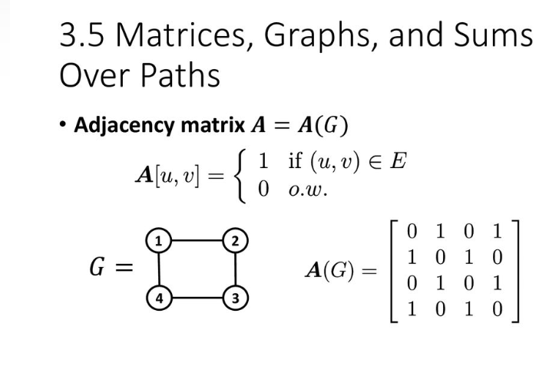
Case Study-

To create a quantum gate from a unitary matrix in Qiskit, you can follow these steps:
Step 1: Import the necessary libraries and set up the quantum circuit.
from qiskit import QuantumCircuit, transpile, assemble, Aer, execute
# Create a quantum circuit with the required number of qubits num_qubits = 2 qc = Quantum Circuit(num_qubits)
Step 2: Define the unitary matrix you want to use as the gate.
import numpy as np
# Define the unitary matrix (example: Hadamard gate) unitary_matrix = np.array([[1, 1], [1, -1]]) / np.sqrt(2)
Step 3: Apply the unitary matrix as a gate to the quantum circuit.
# Apply the unitary matrix as a gate to the circuit
qc.unitary(unitary_matrix, [0, 1]) # Apply the gate to qubits 0 and 1
Step 4: Visualize the quantum circuit.
print(qc)
Step 5: Simulate and execute the quantum circuit to obtain the results.
# Simulate the quantum circuit
simulator = Aer.get_backend('statevector_simulator')
job = execute(qc, simulator)
result = job.result()
# Get the final state vector
statevector = result.get_statevector()
print("Final state vector:")
print(statevector)

Unit 2 - Quantum Architecture

Quantum architecture refers to the physical design and layout of quantum computing systems, including the hardware components and their interconnections. Quantum computing aims to harness the principles of quantum mechanics to perform computations that are beyond the capabilities of classical computers.

Unlike classical computers that use bits to represent information as either 0 or 1, quantum computers use quantum bits, or qubits, which can represent 0, 1, or both states simultaneously, a phenomenon known as superposition. This property of superposition allows quantum computers to perform certain calculations exponentially faster than classical computers for specific tasks.

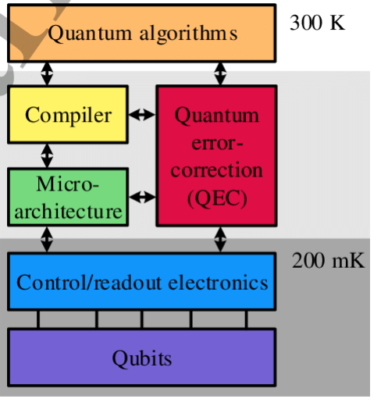

Quantum architecture involves several key components:

- Qubits: These are the basic building blocks of quantum computing and are the quantum analogs of classical bits. Qubits are typically implemented using physical systems such as superconducting circuits, trapped ions, or topological qubits.

- Quantum Gates: Quantum gates are the quantum counterparts of classical logic gates. They manipulate qubits, enabling quantum computers to perform quantum algorithms. Common quantum gates include Hadamard gate, CNOT (Controlled-NOT) gate, and Toffoli gate, among others.

- Quantum Registers: A quantum register is a group of qubits that can be manipulated together to perform specific quantum operations.
- Quantum Circuits: Quantum circuits are sequences of quantum gates applied to qubits in a specific order to execute quantum algorithms. They represent the quantum version of classical computer programs.
- Quantum Interconnects: Quantum interconnects are the physical connections between qubits that allow for communication and entanglement, a crucial property in quantum computing that enables quantum parallelism and enhanced computational power.
- Error Correction: Quantum computations are susceptible to errors caused by environmental noise and decoherence. Quantum error correction techniques are used to protect quantum information from such errors and ensure reliable computations.
- Cooling and Isolation: Quantum computers need to be operated at extremely low temperatures to maintain the delicate quantum states of qubits and reduce interference from the environment.
- Control Systems: Control systems are responsible for applying the correct sequences of quantum gates and measurements to the qubits.

The Framework of Quantum Mechanics
Quantum mechanics is a fundamental framework of physics that describes the behavior of particles and systems at the atomic and subatomic scales. It is a cornerstone of modern physics and has been highly successful in explaining a wide range of phenomena that classical mechanics and classical electromagnetism cannot account for. The framework of quantum mechanics is built on several key principles and mathematical formalisms:

Wave-Particle Duality: One of the most intriguing aspects of quantum mechanics is the wave-particle duality, which suggests that particles, such as electrons and photons, exhibit both wave-like and particle-like properties. This means that these particles can behave as discrete entities (particles) and spread out as waves, depending on the experimental setup.

Superposition: Quantum superposition is the principle that a quantum system can exist in multiple states simultaneously. For example, a qubit in a quantum computer can be in a state representing both 0 and 1 at the same time.

Quantum States and Wavefunctions: The quantum state of a particle or a system is described by a mathematical entity called a wavefunction (also known as a state vector). The wavefunction encodes the probability amplitude for finding the particle in various states upon measurement.

Uncertainty Principle: The Heisenberg uncertainty principle is a fundamental concept in quantum mechanics, stating that certain pairs of physical properties, such as position and momentum, cannot be simultaneously measured with arbitrary precision. This introduces inherent uncertainty into quantum systems.

Measurement and Collapse: When a quantum system is measured, the wavefunction "collapses" into one of its allowed states, with the probability of each state determined by the square of the amplitude of its corresponding wavefunction component. This process is inherently probabilistic.

Entanglement: Entanglement is a unique quantum phenomenon where two or more particles become correlated in such a way that the state of one particle is instantly related to the state of the others, regardless of the distance between them. This property is at the heart of quantum information processing and quantum teleportation.

Operators and Observables: In quantum mechanics, physical observables, such as position, momentum, and spin, are associated with mathematical operators. These operators act on the wavefunction, allowing us to calculate the expected values of observables in a quantum system.

Schrödinger Equation: The Schrödinger equation is a central equation in quantum mechanics that describes how the wavefunction of a quantum system evolves over time. It links the energy of the system with the time evolution of its wavefunction.

The mathematics of quantum mechanics is primarily based on linear algebra and Hilbert space, providing a formal and powerful language to describe and predict the behavior of quantum systems. Quantum mechanics has wide-ranging applications, including in quantum computing, quantum cryptography, condensed matter physics, and particle physics, among others. Despite its tremendous success, quantum mechanics still presents philosophical questions and challenges our intuitive understanding of reality at the quantum level.

The State of a Quantum System :

The state of a quantum system is a fundamental concept in quantum mechanics that describes the quantum properties and behavior of the system. In classical physics, the state of a system can be fully described using its position and momentum, which are represented as points in phase space. In quantum mechanics, the state of a quantum system is more complex and is described by a mathematical entity known as the wave function (or state vector).

The wave function contains all the information about the quantum system, including the probabilities of finding the system in various states upon measurement. In particular, the square of the amplitude of the wave function at a given point represents the probability of finding the system in a specific state.

The state of a quantum system can be represented as a superposition of multiple states. This property is known as quantum superposition, and it allows quantum systems to exist in a combination of different states simultaneously. For example, a qubit in a quantum computer can be in a state representing both 0 and 1 at the same time.

Mathematically, the state of a quantum system is denoted by the wave function |Ψ⟩,

Quantum State (Wavefunction)

|Ψ⟩ = α|0⟩ + β|1⟩

where the symbol "|" represents a ket vector in the mathematical formalism of quantum mechanics. The wavefunction |Ψ⟩ is an element of a complex vector space, typically represented using the Dirac notation in the Hilbert space.

|Ψ⟩ represents the quantum state (wavefunction) of the quantum system.
α and β are complex probability amplitudes representing the coefficients of the quantum state |0⟩ and |1⟩, respectively.
|0⟩ and |1⟩ are the basis states of a qubit, representing the "0" and "1" states, respectively.
The state of a quantum system can be described as a superposition of basis states, such as |0⟩ and |1⟩ for a qubit, with associated probability amplitudes α and β. When the system is measured, it will collapse to one of the basis states (|0⟩ or |1⟩) with a probability proportional to the square of the amplitude of that state. The probability of measuring |0⟩ is |α|^2, and the probability of measuring |1⟩ is |β|^2.

The state of a quantum system evolves over time according to the Schrödinger equation, which is a central equation in quantum mechanics. The Schrödinger equation determines how the wavefunction changes as a function of time, and it governs the dynamics of the quantum system.

The time-dependent Schrödinger equation for a single non-relativistic particle (such as an electron) is given by:

iħ ∂ψ(x, t)/∂t = -ħ^2/(2m) ∂^2ψ(x, t)/∂x^2 + V(x)ψ(x, t)

Here,

ħ (h-bar) is the reduced Planck constant, equal to the Planck constant (h) divided by 2π. It appears to relate the energy scale to the time scale in quantum mechanics.

ψ(x, t) is the wavefunction of the particle, representing the quantum state of the system at position x and time t. The wavefunction is a complex-valued function.

i is the imaginary unit (√(-1)).

∂/∂t represents the partial derivative with respect to time t.

∂^2/∂x^2 represents the second partial derivative with respect to position x.

m is the mass of the particle.

V(x) is the potential energy function that depends on the position x.
When a measurement is made on a quantum system, the wave function collapses to one of the possible states corresponding to the measurement outcomes. The probability of collapsing to a particular state is given by the square of the amplitude of that state's component in the wavefunction.

It is important to note that the state of a quantum system is inherently probabilistic. Unlike classical physics, where measurements precisely determine the state of a system, quantum mechanics only provides probabilities for the outcomes of measurements. The act of measurement changes the state of the system, and subsequent measurements may yield different outcomes due to the probabilistic nature of quantum mechanics.

In summary, the state of a quantum system is described by a wavefunction that contains all the information about the system's quantum properties. This wavefunction can be in a superposition of multiple states, and it evolves over time according to the Schrödinger equation. When measured, the state collapses to one of the possible outcomes with probabilities given by the square of the amplitudes of the corresponding components in the wavefunction. The probabilistic nature of quantum mechanics is one of the key differences that distinguishes it from classical physics.

